Rail Lift

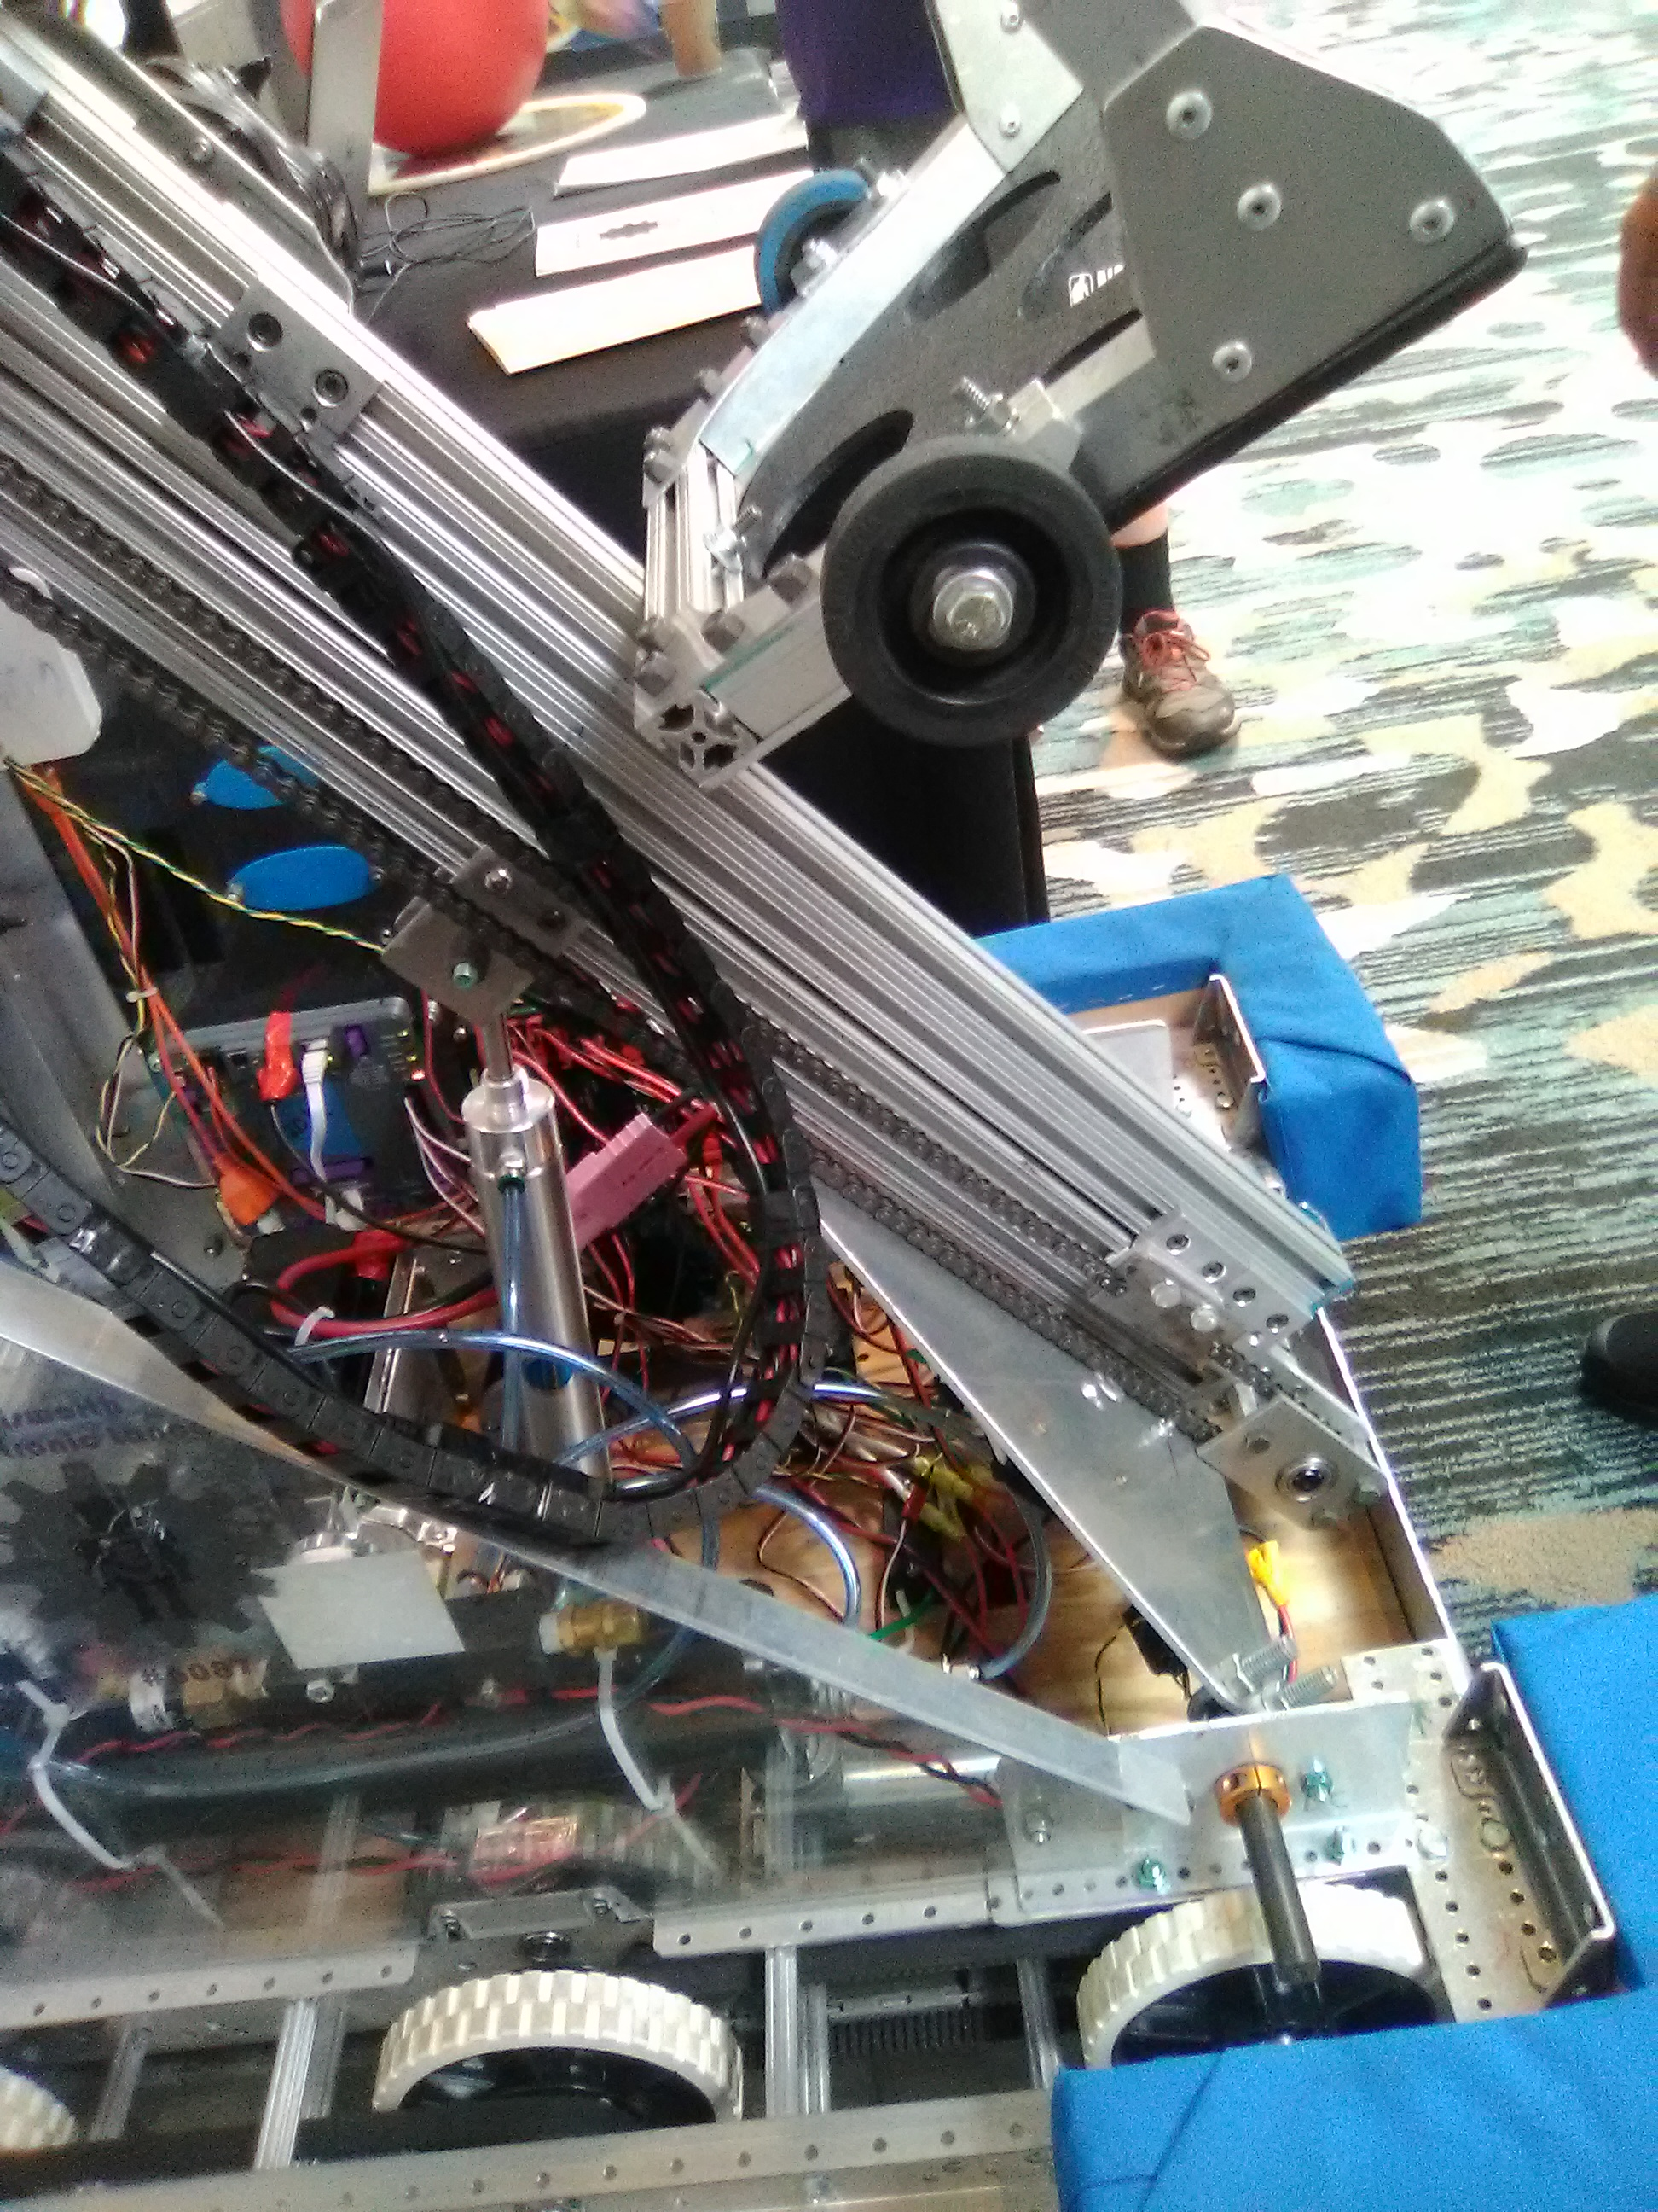

Pneumatic lift

Cylinder Diameter : xx inches

Cylinder Stroke : xx inches

Cylinder control : Dual pneumatic control solenoid

Pneumatic pressure : xx psi

Actuation force : piston area x pressure

Lift mounting plate 3/16 aluminum plate

Pivot shaft 5/8 hard anodized aluminum

Pivot bearings 5/8 ID flange mounting

Shaft collars each end for retention

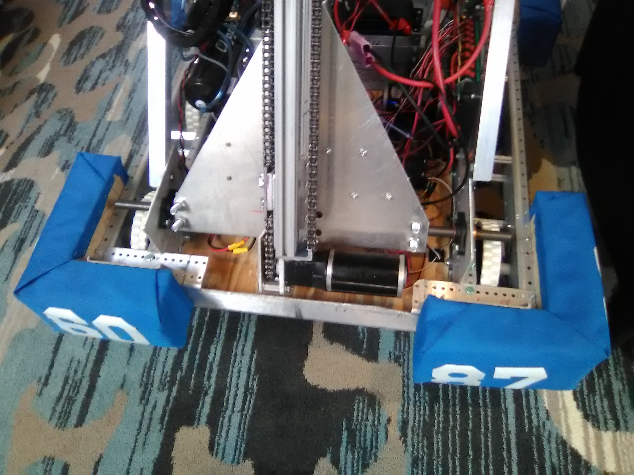 Secondary Ball Lift

8020 1020 extrusion

1010 single short unibearings

10 series double keyed bearing pads between rails

Chain drive

12 tooth drive sprocket

12 tooth idler sprocket with bronze bushing

Activation Cim Motor

Vexpro Versa planetary gearbox

5:1 and 7:1 gearsets

35:1 final drive ratio

Primary Ball Lift

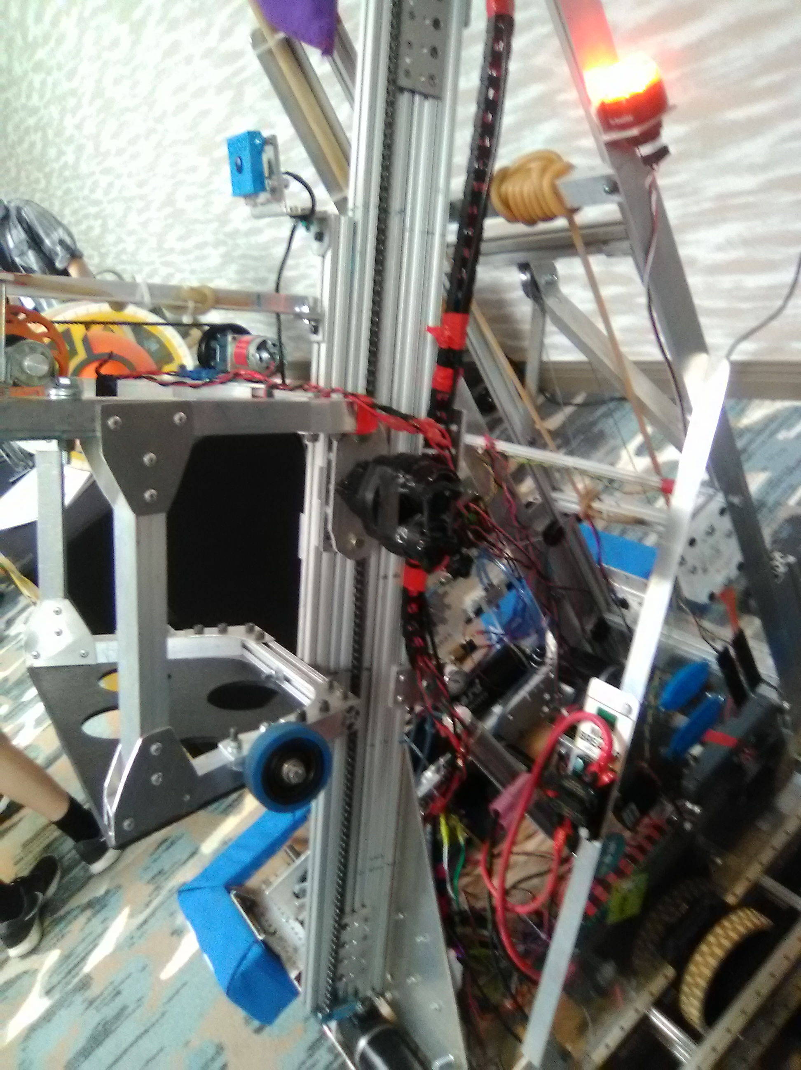

8020 1020 extrusion

1010 single short unibearings

10 series double keyed bearing pads between rails

Chain drive fixed chain ends

12 tooth drive sprocket

Dual 12 tooth idler sprockets with bronze bushings

Activation Dual Vex 775 motors with Versa DM gearbox

Vexpro Versa planetary gearbox

5:1 and 7:1 gearsets

35:1 Final drive ratio

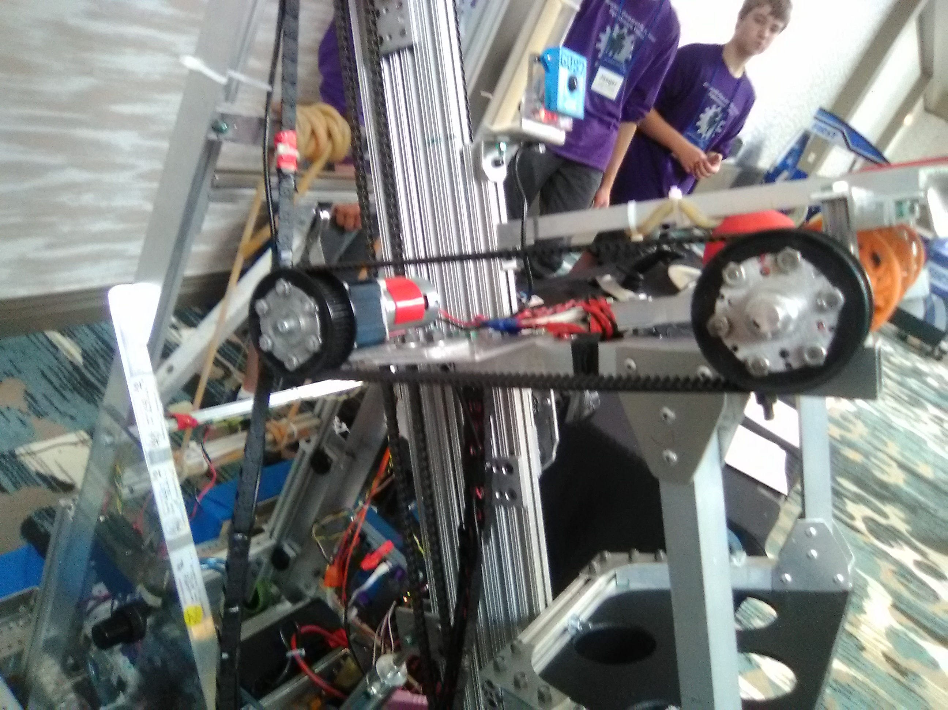 Ball Shooter

Activation Andymark 775a Redline Motor

4:1 planetary gearbox

Andymark 500 EX drive hubs

42 tooth pulleys?

92 tooth HTD timing belt?

½ inch 2024-T3 aluminum drive shaft

Triangle bearing pillow block support bearings

3 inch compliant wheels ?

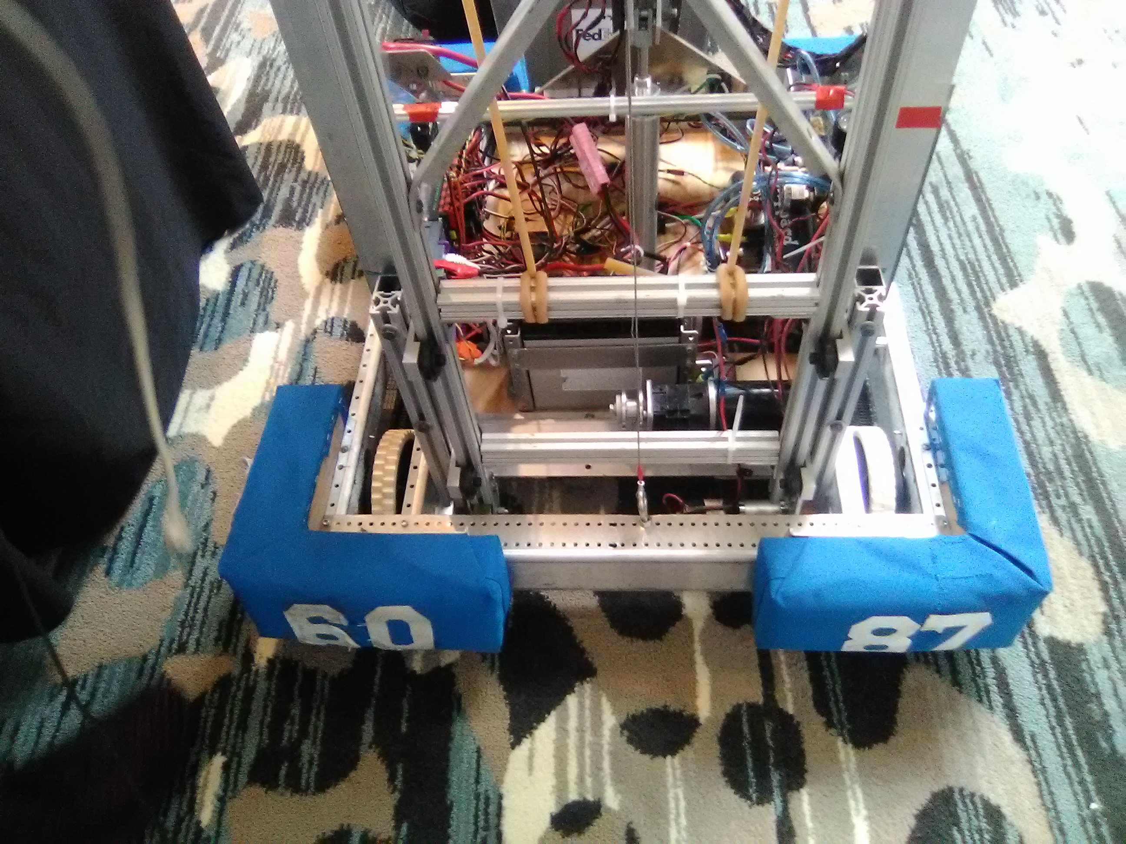 Robot Rear Lift

8020 1010 extrusion

8020 1 inch roller wheel bracket assembly, 4 are used

10 series double keyed bearing pads between rails

1/16 cable driveActivation Dual Vex 775 motors with Versa DM gearbox

Vexpro Versa planetary gearbox

5:1 and 7:1 gearsets

35:1 Final drive ratio

Disc Grabber

Pneumatic Block Diagram

Electrical Block Diagram

Electrical Wiring Diagram